**Machine learning**

Adrian Mackenzie

In flight, en route to Copenhagen, I find myself staring, transported, at a line of maths, an expression of a basic model in machine learning. It’s a polished proposition Latour (2004), a way of putting forward the kernel of what machine learning does when it classifies. Carefully, I inscribe the expression on a paper napkin that came with the in-flight refreshment.

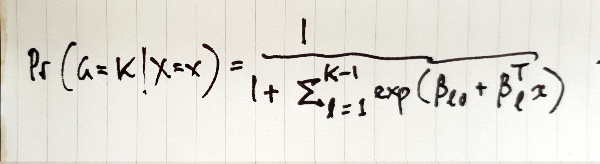

Logistic regression; Hastie, Tibshirani, and Friedman (2009, 119)

Do I think tracing it ontp a napkin puts it in the world more than the many copies printed in PDFs, textbooks, websites and online videos? Or that it puts it in me? Do I mobilise it by t it?

In scope, the expression matches Donna Haraway’s marvelous integral equation for a post-hummus life in Terrapolis, a speculative ‘fictional n-dimensional niche-space for multispecies becoming with’ Haraway (2016, 10-11).  
In isolation, the proposition, refractory and opaque as it may seem, is a strange mixture of vast emptiness – the long distances the flight covers without my noticing – and densely woven differences, forces, relations, practices and associations – the crowded cabin. There’s so much compacted and implicit in this expression, the archetypal classifier known as logistic regression. It compresses so much in its indices, its $X$ and x-es, and the elementary operations of adding and dividing. It runs through machine learning, from Facebook to self-driving cars, from biomedical statistics to Tiktok, from recommendation engines to border security, classifying wherever it goes.

The proposition says something like: things in the world can be sorted into $K$ classes, perhaps even just two classes, like the passengers sitting fore and aft on this flight, or people who live and people who die. The degree of belief (a.k.a probability) that a thing, a passenger, sits in a particular class depends on all the data relating to that thing, $x$. The dependency can be written as a fraction: one over the sum of values of data, a sum weighted by the unobtrusive parameters $β$. The values of $β$ are the object of extensive tuning during the ‘learning’ or ‘training’ phases of machine learning. They are control surfaces. Their alignment and position channels movement through the model.

Sunlight floods through the window as the take-off clears the low cloud over Manchester. From up high, the traffic beetling on the motorways, the rivers and wooded streams, sheep stood in marshy fields, the warehouses and distribution centres clustering near motorway exits, shopping malls and leisure complexes on urban peripheries, and the winding rows of houses, spread out like an actor-network quilt.

Is the equation a landscape painting, a view from on high? Is it a flight path, a trail of condensed vapour? Machine learning keeps opening up new destinations, like a low-cost airline that crams millions of passengers on flights to a thousand hitherto far-flung resorts. Or is it, as William James (1935) might see it, a form of experience like the security lanes at Terminal 1 Manchester Airport, a path trodden by millions, including people like me, carried along by their susceptibilities to the dazzle of a takeoff. We wind through it, subscripted, superscripted and supervised, passing through gates such as the ‘bias’ $β_{0}$, feeling the weights of the model parameters $\hat{β}$, pulled apart by the exponential function, and lined up again by the summing operator $σ$, the operator those nod says ‘yes, go through’, or ‘no, stand here.’ Is it a full body scanner in which we stand with arms raised Benjamin (2019), Amoore (2020)?

The stark simplicity of the expression still dazzles me almost as much as it did in 2014 (Mackenzie 2017), but there is no flight without the queues, scans and controls, logistics and marketing, all the costs and losses of movement. If I am transported by a technique, dazzled by it, how do I move? The dazzle of technicalities rarely benefits understandings of technical practice, except perhaps in this one respect: we need to be somehow transported for there to be experience of them. ‘It is only by risking our persons from one hour to another that we live at all’ writes James in his movement-based account of experience (James,1956, 34). I carried the napkin around for a long time after the flight. I see the expression now not so much as a full body scanner, or a landscape viewed from far above, but something to be traced out, copied, followed up, even carried away on a paper napkin, after the flight has ended.

## References

Amoore, Louise. 2020. *Cloud Ethics: Algorithms and the Attributes of Ourselves and Others*. Durham, Duke University Press. <http://ebookcentral.proquest.com/lib/anu/detail.action?docID=6147469>.

Benjamin, Ruha. 2019. *Race After Technology: Abolitionist Tools for the New Jim Code*. Newark, UNITED KINGDOM: Polity Press. <http://ebookcentral.proquest.com/lib/anu/detail.action?docID=5820427>.

Haraway, Donna J. 2016. *Staying with the Trouble: Making Kin in the Chthulucene*. Durham London: Duke University Press.

Hastie, Trevor, Robert Tibshirani, and Jerome Friedman. 2009. *The Elements of Statistical Learning: Data Mining, Inference, and Prediction*. 2nd ed. London & New York: Springer International Publishing.

James, William. 1935. *The Varieties of Religious Experience; a Study in Human Nature*. London, New York [etc.]: Longmans, Green and co.

———. 1956. *The Will to Believe: And Other Essays in Popular Philosophy, and Human Immortality*. Courier Corporation.

Latour, B. 2004. “Why Has Critique Run Out of Steam? From Matters of Fact to Matters of Concern.” *Critical Inquiry* 30 (2): 225–48.

Mackenzie, Adrian. 2017. *Machine Learners: Archaeology of a Data Practice*. Cambridge, MA: MIT Press.